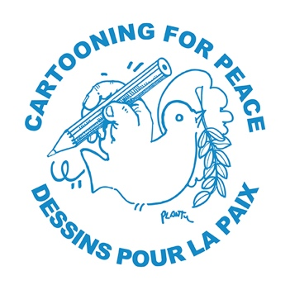

Looking back at 2017: Human Rights in Comics!

FIDH (International Federation for Human Rights)
Cartooning for Peace

Check out the comic strip version of our Annual Report
Interactive map:
https://www.fidh.org/en/impacts/our­actions­in­2017
In Dazibao format:
https://www.fidh.org/en/impacts/fidh­looks­back­at­2017­in­our­traditional­comic­strip
Share it on social networks
Via Facebook https://www.facebook.com/FIDH.HumanRights
Retweet the report
https://twitter.com/fidh_fr and https://twitter.com/fidh_en

Paris, 2 February 2018 - Extremism and populism on the rise, lasting deadly conflicts, escalated terrorist attacks, security overplay, and primacy of economic and trade interests: throughout the world human rights are under attack, threatened, or simply relegated to the rank of nice but illusory. And yet, they resist! Today, FIDH publishes the comic strip version of its Annual Report created by graphic artist Romain Ronzeau and the graphic artists from Cartooning for Peace. Illustrating some of the victories and battles of 2017, the artists eloquently convey the essential: in times of crises, defending human rights is more necessary than ever!
The comic-strip version of the FIDH Annual Report illustrates the opening of an inquiry by the International Criminal Court on the authoritarian regime in Burundi, the partial legalisation of abortion in Chile, the passing of historic law to end violence against women in Tunisia, and the disclosure of ties between French banks and Israeli occupation.

The Annual Report published online today describes some of the many human rights battles fought in 2017 by FIDH and its 184 member organisations around the world: the wide diversity of successes and their consequences.

The 7th FIDH comic-strip Annual Report is a collaborative work created by graphic artist Romain Ronzeau and the graphic artists from Cartooning for Peace. The comic strip report is presented as an interactive map where online users can click on a country or theme. The illustrations used for the report can be shared on social media!

On the occasion of the comic strip Annual Report's release, FIDH reaffirms its support for all graphic artists and caricaturists who are subjected to threats and attacks on a daily basis.

Cartooning for Peace is a network of 162 editorial cartoonists who fight, through humour, for the respect of cultural diversity and freedoms. Founded by Plantu in 2006 and placed under the patronage of Kofi Annan, the association is committed to the promotion of editorial cartoon as a means of defending human rights and freedom of speech through events, publications and exhibitions ; the use of cartoons’ pedagogical value to denounce all forms of intolerance and to raise young and vulnerable people’s awareness about major social issues ; and to provide visibility to threatened cartoonists.

Media contacts:

Samuel Hanryon
shanryon@fidh.org / Twitter: @Sam_hanryon

Audrey Couprie
acouprie@fidh.org / Twitter: @AudreyCouprie

